**Experiment No:** 7  **Date:** 10/04/2021

**Aim:** Implementation of Single Source Shortest Path Algo

(Dijkstra's Algo) and estimate its step count

**Theory:**

**Dijkstra’s Shortest Path Algorithm**

* Given a graph and a source vertex in the graph, find shortest paths from source to all vertices in the given graph.
* Dijkstra’s algorithm is very similar to Prim’s algorithm for minimum spanning tree.
* Like Prim’s MST, we generate a SPT (shortest path tree) with given source as root.
* We maintain two sets, one set contains vertices included in shortest path tree, other set includes vertices not yet included in shortest path tree.
* At every step of the algorithm, we find a vertex which is in the other set (set of not yet included) and has a minimum distance from the source.

**Time Complexity**

* The time complexity of the above code/algorithm looks O(V^2) as there are two nested while loops.
* If we take a closer look, we can observe that the statements in inner loop are executed O(V+E) times (similar to BFS).
* The inner loop has decreaseKey() operation which takes O(LogV) time.
* So overall time complexity is O(E+V)*O(LogV) which is

***O((E+V)*LogV) = O(ELogV)***

* Note that the above code uses Binary Heap for Priority Queue implementation.
* Time complexity can be reduced to ***O(E + VLogV)*** using Fibonacci Heap.
* The reason is, Fibonacci Heap takes O(1) time for decrease-key operation while Binary Heap takes O(Logn) time.

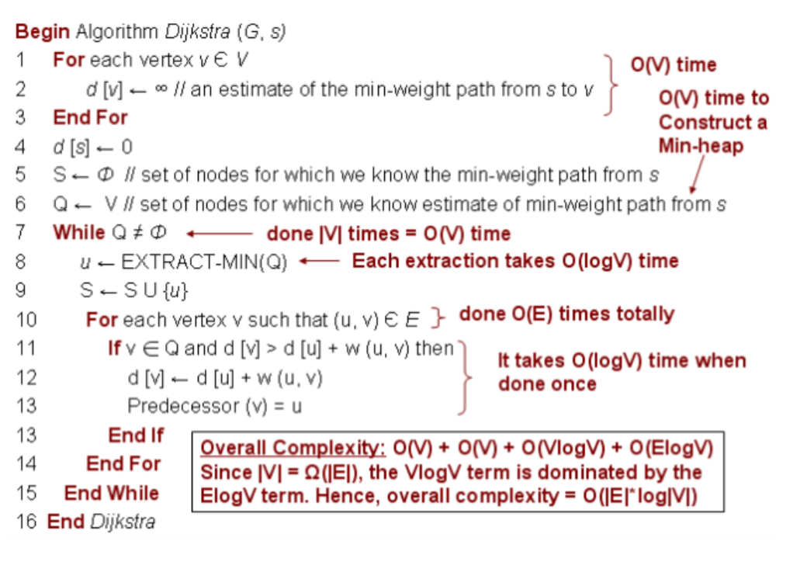

**Algorithm**

Algorithm ShortestPaths(v,cost,dist,n)

// dist[j], 1<jn, is set to the length of the shortest

// path from vertex v to vertex j in a digraph G with n

// vertices. dist[v] is set to zero. G is represented by its

// cost adjacency matrix cost[1: n. 1:n].

{

for i:=1 to n do

{ // Initialize S.

S[i]:= false; dist[i]:= cost[v, i];

}

S[v]:= true; dist[v] := 0.0; // Put v in S.

for num=2 to n - 1 do

{

// Determine n - 1 paths from v.

Choose u from among those vertices not

in S such that dist[u] is minimum;

S[u]:= true; // Put u in S.

for (each w adjacent to u with S[w] = false) do

// Update distances.

if (dist[w]> dist[u] + cost[u, w])) then

dist[w]: dist[u] + cost[u, w];

}

}

**Algorithm writing**

1. Mark your selected initial node with a current distance of 0 and the rest with infinity.
2. Set the non-visited node with the smallest current distance as the current node C.
3. For each neighbour N of your current node C:
   * add the current distance of C with the weight of the edge connecting C-N.
   * If it's smaller than the current distance of N, set it as the new current distance of N.
4. Mark the current node C as visited.
5. If there are non-visited nodes, go to step 2.

**Tracing with Example**

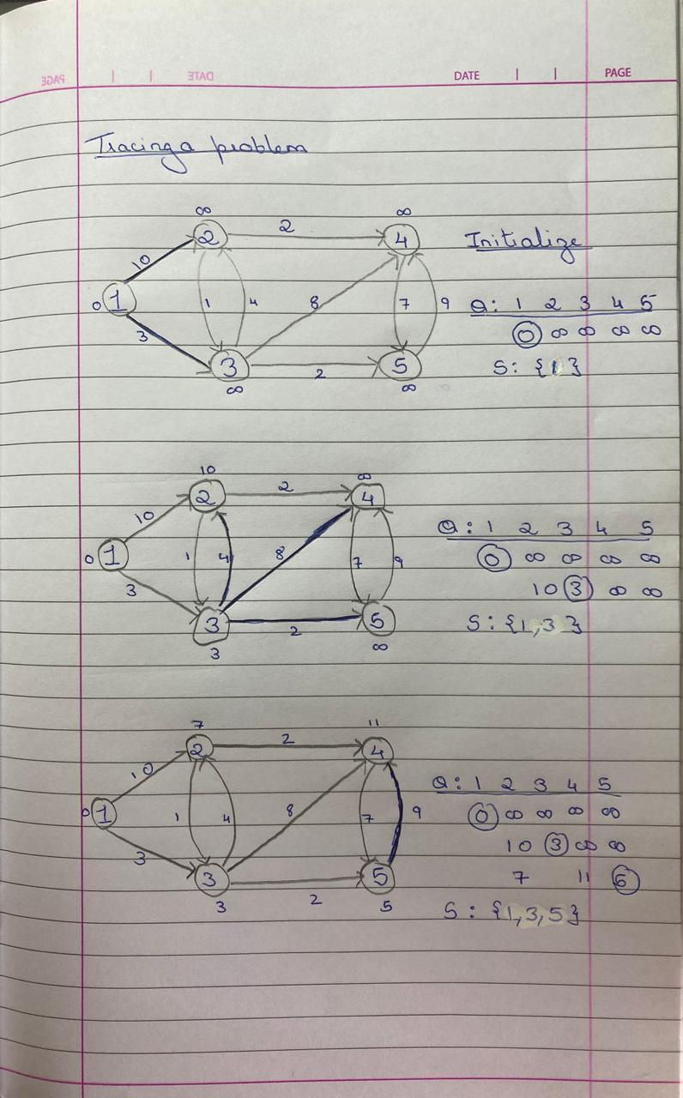

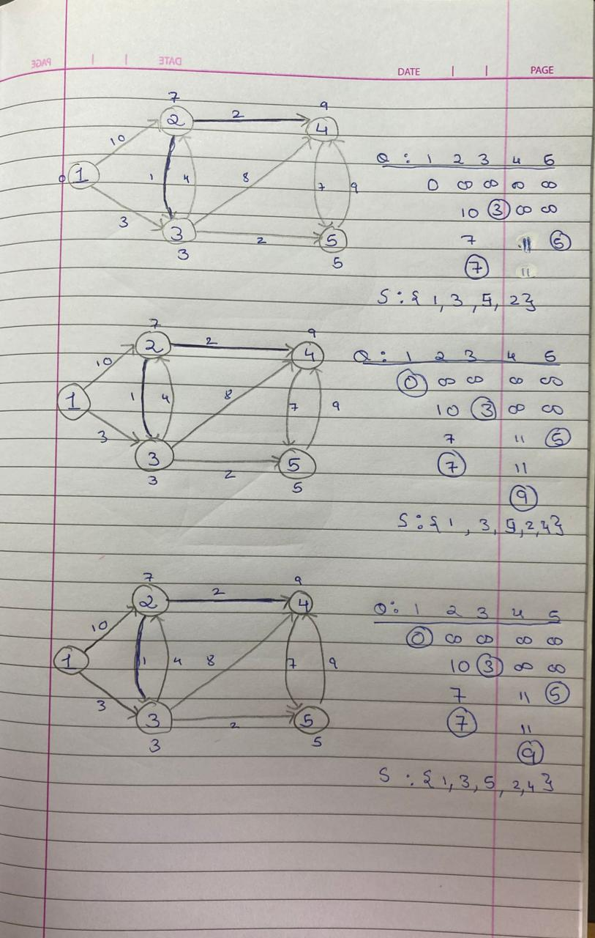

**Program**

#include<iostream>

using namespace std;

#define V 6

int stepcount=0;

int minDistance(int dist[], bool sptSet[])

{

int min = INT_MAX;stepcount++;

int min_index;

for (int v = 0; v < V; v++)

{

stepcount++;

stepcount++;

if (sptSet[v] == false && dist[v] <= min)

{

min = dist[v], min_index = v;stepcount++;

}

}

stepcount++;

return min_index;

}

void printSolution(int dist[])

{

cout<<"Vertex \t\t Distance from Source"<<endl;stepcount++;

for (int i = 0; i < V; i++)

{

stepcount++;

cout<<i<<"\t\t\t"<<dist[i]<<endl;stepcount++;

}

}

void dijkstra(int graph[V][V], int src)

{

int dist[V];

bool sptSet[V];

for (int i = 0; i < V; i++)

{

stepcount++;

dist[i] = INT_MAX, sptSet[i] = false;stepcount++;

}

dist[src] = 0;stepcount++;

for (int count = 0; count < V - 1; count++)

{

stepcount++;

int u = minDistance(dist, sptSet);stepcount++;

sptSet[u] = true;stepcount++;

for (int v = 0; v < V; v++)

{

stepcount++;

stepcount++;

if (!sptSet[v] && graph[u][v] && dist[u] != INT_MAX

&& dist[u] + graph[u][v] < dist[v])

{

dist[v] = dist[u] + graph[u][v];stepcount++;

}

}

}

stepcount++;

printSolution(dist);

}

int main()

{

int graph[V][V];

cout<<"Enter the vertices for a graph with 6 vetices:";stepcount++;

for (int i=0;i<V;i++)

{

stepcount++;

for(int j=0;j<V;j++)

{

stepcount++;

cin>>graph[i][j];stepcount++;

}

}

stepcount++;

dijkstra(graph, 0);

cout<<"*************"<<endl;

cout<<"Stepcount:"<<stepcount<<endl;

cout<<"*************"<<endl;

return 0;

}

**Output**

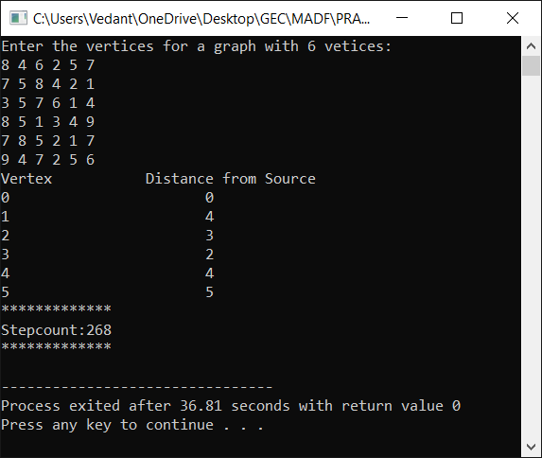

**Conclusion**

* Detailed concept of Single Source Shortest Path Algo (Dijkstra's Algo)was studied successfully.
* Program using Dijkstra's Algorithm was executed successfully.
* The step count for the Dijkstra's Algorithm was obtained.